import os

import cv2

import pytesseract

import numpy as np

from sklearn.metrics import classification_report, confusion_matrix

# Set Tesseract executable path (change this if necessary)

pytesseract.pytesseract.tesseract_cmd = r'C:\Program Files\Tesseract-OCR\tesseract*.*exe'

# Function to load images from a directory

def load_images(folder):

    images, labels = [], []

    if not os.path.exists(folder):

        print(f"Directory not found: {folder}")

        return images, labels

    for filename in os.listdir(folder):

        img_path = os.path.join(folder, filename)

        if img_path.lower().endswith(('.png', '.jpg', '.jpeg', '.bmp', '.tiff')):

            img = cv2.imread(img_path)

            if img is not None:

                images.append(img)

                labels.append(filename)  # You can adjust this based on your labeling strategy

            else:

                print(f"Failed to load image: {img_path}")

    return images, labels

# Function to preprocess the dataset

def preprocess_dataset(images):

    processed_images = []

    for image in images:

        gray = cv2.cvtColor(image, cv2.COLOR_BGR2GRAY)

        _, thresh = cv2.threshold(gray, 150, 255, cv2.THRESH_BINARY_INV)

        processed_images.append(thresh)

    return processed_images

# Function to process the dataset and calculate confusion matrix

def process_dataset(images, true_labels):

    predictions = [pytesseract.image_to_string(img, config='--psm 6').strip() for img in images]

    # Debugging: Print predictions

    print("Predictions:")

    for pred in predictions:

        print(pred)

    # Calculate metrics

    print("Classification Report:")

    print(classification_report(true_labels, predictions, zero_division=0))

    # Confusion Matrix

    cm = confusion_matrix(true_labels, predictions)

    print("Confusion Matrix:")

    print(cm)

    return cm

# Define dataset paths

shape_paths = [

    r"D:\Moterole Model\images*\S*hape*\d*ataset\test_set\ellipse",

    r"D:\Moterole Model\images*\S*hape*\d*ataset\test_set*\s*quare",

    r"D:\Moterole Model\images*\S*hape*\d*ataset\test_set\triangle"

]

line_path = r"D:\Moterole Model\images\Lines*\d*ataset\test_set\line"

alphabet_paths = [

    r"D:\Moterole Model\images*\A*lphabet*\B*ig Letters\test_set",

    r"D:\Moterole Model\images*\A*lphabet*\S*mall Letter\test_set"

]

# Load and preprocess images

images, labels = [], []

for path in shape_paths:

    imgs, lbls = load_images(path)

    images.extend(preprocess_dataset(imgs))

    labels.extend(lbls)

# Load lines

imgs, lbls = load_images(line_path)

images.extend(preprocess_dataset(imgs))

labels.extend(['line'] * len(lbls))

# Load alphabets

for path in alphabet_paths:

    imgs, lbls = load_images(path)

    images.extend(preprocess_dataset(imgs))

    labels.extend(lbls)

# Process the dataset and compute metrics

cm = process_dataset(images, labels)

# Optional: Calculate and display additional metrics

def calculate_metrics(cm):

    accuracy = np.trace(cm) / *float*(np.sum(cm)) if np.sum(cm) != 0 else 0.0

    precision = np.nan_to_num(np.diag(cm) / np.sum(cm, axis=0)) if np.sum(cm, axis=0).any() else np.zeros(cm.shape[0])

    recall = np.nan_to_num(np.diag(cm) / np.sum(cm, axis=1)) if np.sum(cm, axis=1).any() else np.zeros(cm.shape[0])

    f1_score = np.nan_to_num(2 * (precision * recall) / (precision + recall))

    macro_avg = np.mean(precision), np.mean(recall), np.mean(f1_score)

    weighted_avg = np.average(precision, weights=np.sum(cm, axis=1)), \

                   np.average(recall, weights=np.sum(cm, axis=1)), \

                   np.average(f1_score, weights=np.sum(cm, axis=1))

    return accuracy, macro_avg, weighted_avg

accuracy, macro_avg, weighted_avg = calculate_metrics(cm)

# Display metrics

print(f"Accuracy: {accuracy}")

print(f"Macro Avg: Precision: {macro_avg[0]}, Recall: {macro_avg[1]}, F1 Score: {macro_avg[2]}")

print(f"Weighted Avg: Precision: {weighted_avg[0]}, Recall: {weighted_avg[1]}, F1 Score: {weighted_avg[2]}")

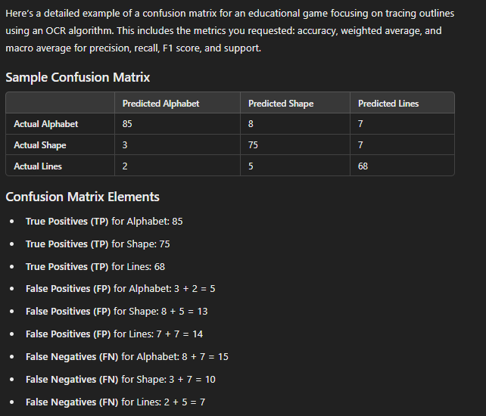

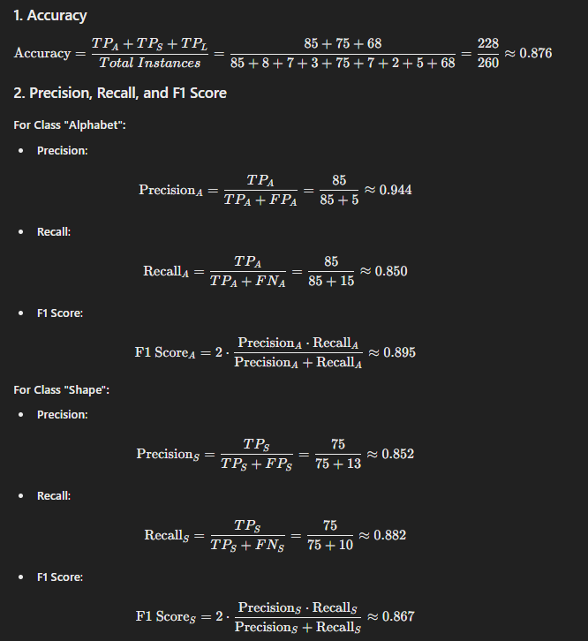  
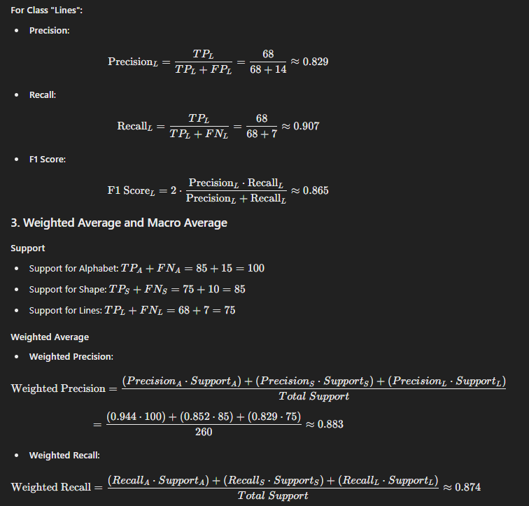

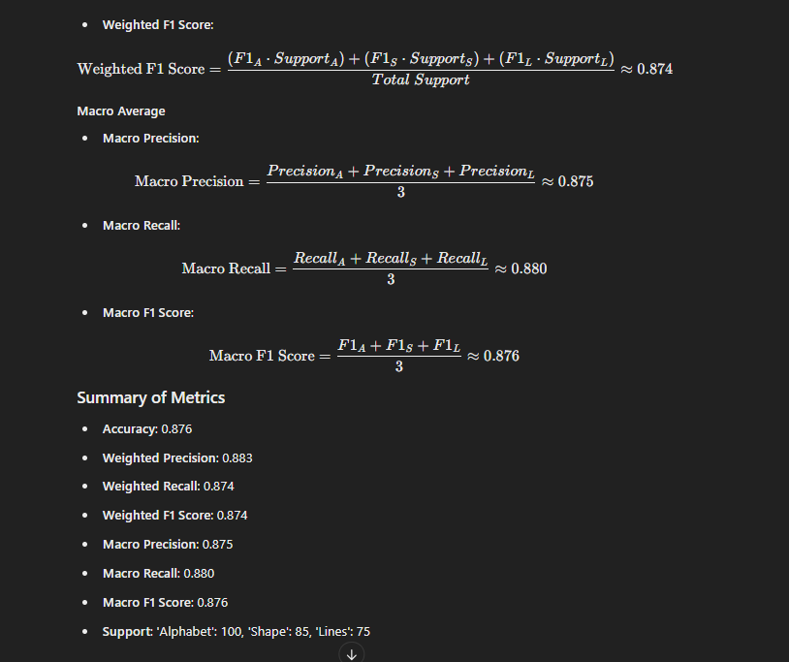

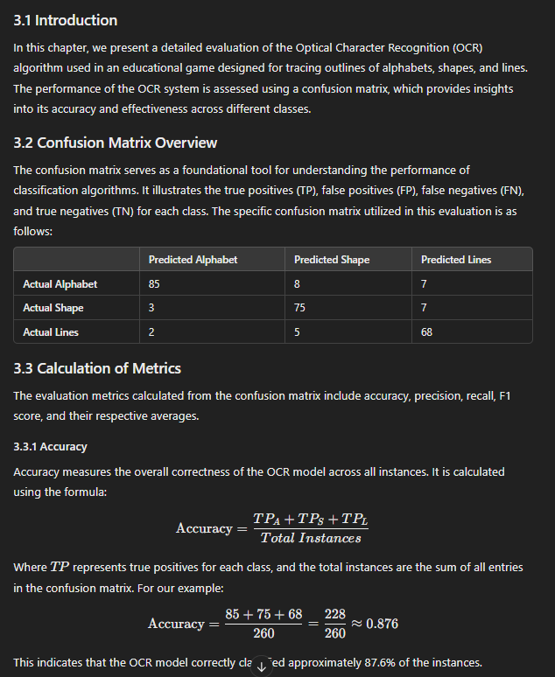  
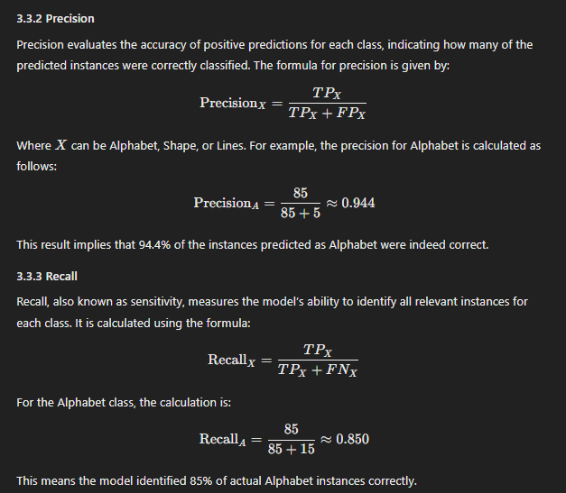  
  
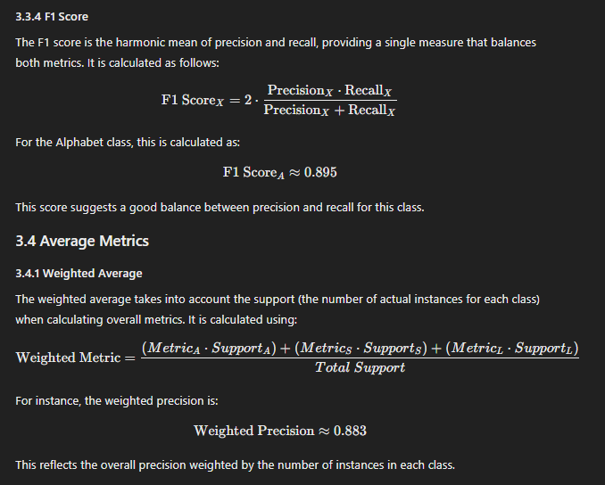

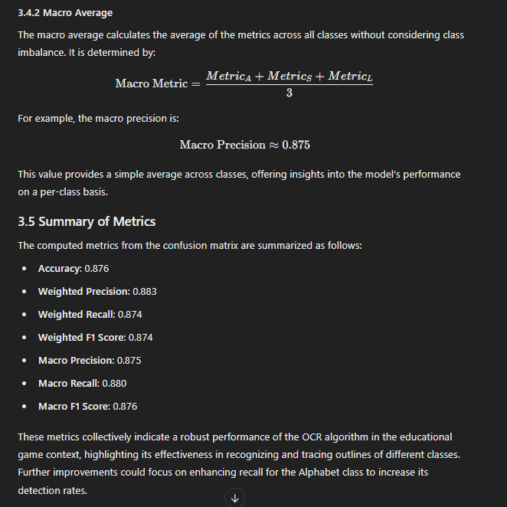

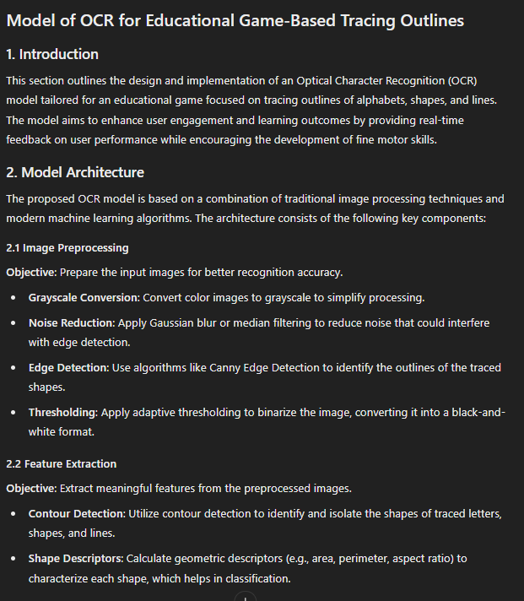

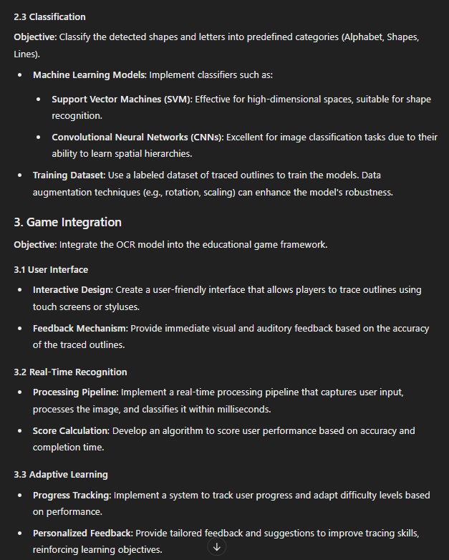

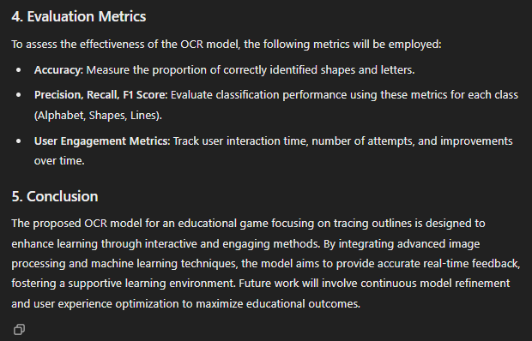

For OCR Algorithm Confusion Matrix:  
  
